COMPUTER VISION
ROLL - IRO2017009
MTECH 1st year, RO

Extrinsic Parameters

Camera extrinsic parameters give the complete model of camera calibration with intrinsic parameters as extrinsic parameters give Rotation and translation matrix with respect to world coordinates.
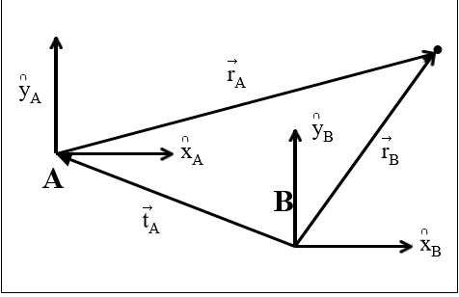

where ta represents the pure translation from frame A to frame B written in frame A coordinates.
Rotation matrices about X , Y and Z axis is given by
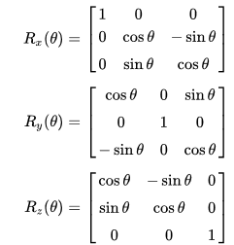

The fundamental equations of perspective projection – assumed the orientation of the camera and world frame known – this is actually a difficult problem known as extrinsic pose problem – using only image information recover the relative position and orientation of the camera and world frames This transformation is typically defined by: – 3-D translation vector T=[x,y,z]T .
Relative positions of each frame – 3x3 rotation matrix, R .This rotates corresponding axes of each frame into each other . R is orthogonal: (RTR = RRT =I).
The homogeneous transform is a mechanism for expressing this form of compound transformation.

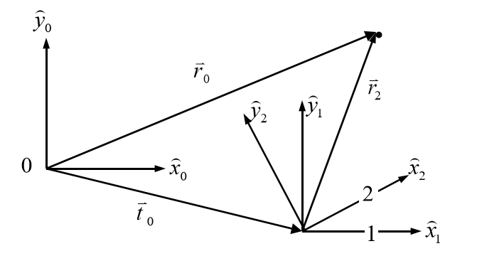

In vector notation, this homogeneous transformation and corresponding homogeneous position vectors are written.
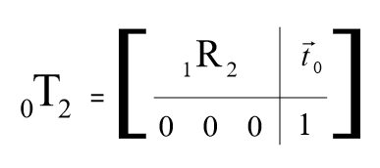

The homogeneous transform provides a convenient means of constructing compound transformations.

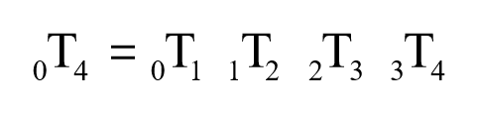

Extrinsic Parameter is given by,

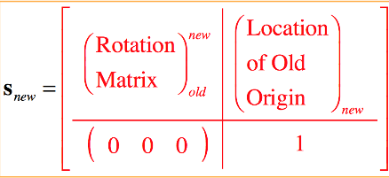

Code :
imageFileNames = {'C:\Users\Mainak Dutta\Desktop\computer vision\calibration\extrinsic1.tif',...
'C:\Users\Mainak Dutta\Desktop\computer vision\calibration\extrinsic2.tif',...

};

[imagePoints, boardSize, imagesUsed] = detectCheckerboardPoints(imageFileNames);
imageFileNames = imageFileNames(imagesUsed);

squareSize = 25;
worldPoints = generateCheckerboardPoints(boardSize, squareSize);

cameraParams = estimateCameraParameters(imagePoints, worldPoints, ...
'EstimateSkew', false, 'EstimateTangentialDistortion', false, ...
'NumRadialDistortionCoefficients', 2, 'WorldUnits', 'mm');

h1=figure; showReprojectionErrors(cameraParams, 'BarGraph');

h2=figure; showExtrinsics(cameraParams, 'CameraCentric');

originalImage = imread(imageFileNames{1});
undistortedImage = undistortImage(originalImage, cameraParams);

Output :

First image :

Rotation matrix :

0.9923 0.0551 0.1107
0.0082 0.8640 -0.5035
-0.1234 0.5005 0.8569

Translation vector :

[-132.146883027131 -140.609919209703 633.715904203759]^{T}

Second Image :

Rotation Matrix :

0.9859 0.1655 -0.0256
-0.1559 0.8515 -0.5006
-0.0611 0.4975 0.8653

Translation Vector :

[-107.395436726271 -153.392842143825 648.533108977074]^{T}

With respective world coordinate system camera is not completely calibrated to each and every axis. Also, camera intrinsic parameters induce distortion in the image. So, the camera is not completely calibrated.

